Michele Cometa
The Lure of the Origins: Paleolithic Art and Contemporary Visual Culture
Italian Academy, 6 October 2015

Does it make sense to consider cave “art”, the art of an immemorial time, as a challenge for contemporary visual culture studies? It might seem an oxymoron, or rather a boutade, a paradox. Yet there are many reasons to believe that this dive into the past in the age of new media, of digital literacy, can show us a way to the future of visual culture and art theory and that it can give us new energy for research.
My argument is basically that cave art, or, better, paleolithic pictures and signs – and I am aware of course that the definition “art” is neither innocent nor neutral – certainly help us to answer some fundamental questions that contemporary visual culture has faced in recent years – mostly in connection with its stepmothers, the traditional art history and aesthetics – if only because cave art studies inevitably shift the research focus from the issue of Art to the issue of Image.
First I would like to discuss some aspects of this statement from the point of view of a naïve beholder, i. e. the “trivial” gaze of everyday culture. Consider, for example, some prehistoric handaxes (fig. 1)!
There is no doubt that these forms still fascinate and seduce our gazes for their perfect (sometimes fearful) simmetry! The shell (Spondylus spinosus), in the heart of the first handhaxe found in Norfolk (England) is «an adventitious element in the stone», as Kenneth Page Oakley, author of a seminal book like Man, the Toolmaker (1942, 1972) has written, and «served the artistic mind’s eye to distinguish» this exceptional Acheulean artifact «in the way that a blazon does on a sword hilt» (Oakley, 1981).
No doubt that we, “naïve beholders”, see this simmetry and this ornament with almost the same eyes of our prehistorical ancestors. Horst Bredekamp has set this anonymus “Muschelmensch” at the beginning of his “bildaktive” theory on the never-ending origins of images. I know: skilled historians could say that our “way of seeing” are totally different, and that we actually don’t perceive the same things, nor the same meanings and that the historical construction of our eye and gazes don’t permit us too see what our ancestors saw…
In spite of everything, our naïve beholder sees a beautiful and intriguing shell in the middle of a useful and pleasant tool! And in the caves we see still today bisons, aurochs, ibexes, humans and symbols in apsis, side chapels and deep hypogea!
Our naïve beholder would see again a comforting “family resemblance” between the cinematic effects of the horses panel at Chauvet (about 40.000 years ago) and the futuristic speed of the Steeplechasing (1930) by Sybil Andrews (fig. 2.1, 2.2), or between the horses of Chauvet and Marey’ chronophotography of the flying pelican (ca. 1882) or the Volo di rondine (1912-3) by Giacomo Balla (fig. 3.1, 3.2). It is not by chance that Werner Herzog used these cinematic effects to underline the family resemblance between his own images and the paleolithic horses and lions in his documentary film The Cave of Forgotten Dreams (2010) and that Siegfrid Giedion has stated: «the representation of movement (is) one of the great preoccupations of prehistoric art, even in the early period» (Giedion, 1962, p. 20).
Yet, these are not simply naïve analogies or “trivial” comparisons. As a matter of fact our paleolithic ancestors tried to develope some tools the we find again and again in our prehistory of cinema. A bone “disk” (fig. 4) from Laugerie-Basse in France shows a chamois whose movement is split on its two faces. As Marc Azéma and Florent Rivère stated «this suggests that the disk might be used to create the illusion of movement by flickering rapidly from one image to the other, a principle later embodied in the thaumatrope, an early modern device involving rotating cards (Azéma, 2012, p. 321) (fig. 5).
As we can see the question of the “dispositif” belongs to our past in the same way how it belongs to our medial obsessions. And this is not a trivial analogy if we see it in the context of our tool-making abilities. As early as 1875 August Pitt-Rivers, one of the founding fathers of the biology of ornament and images, wrote: «In language and in all ideas communicated by word of mouth there is a hiatus between the limits of our knowledge and the origin of culture which can be bridged over, but we may hold in our hand the first tool ever created by the hand of man» (Pitt-Rivers, 1875, p. 31).
I will just underline here the existence of these cinematic devices during the Paleolithic, but this evidence belongs not only to the history of media technologies, but rather also to the history of our relationships to images/pictures animation: from the primitive animism to the animation of Laocoön through the glimmering light of tourches at the Belvedere and at the Louvre (fig. 6), there is only a blink of an eye, indeed (see Freedberg, (1989), 1991, pp. 86-87).

Last but not least: not only is our naïve gaze involved in this history. Our bodies are too. I’m still not sure if the famous handprints of Abstract Expressionism (fig. 7.1, 7.2) are only a “quote” of paleolithic pictures or rather a “re-enactment”, or a “re-experience” of the artist’s body as Judith Butler would say. I don’t know if it is pertinent for Adolph Gottlieb or Jackson Pollock, but this interpretation must be considered when we study Banksy’s graffiti (fig. 7.3).
Whatever we may think about the “modernity” of cave art – by which I mean the parietal art of the caves, as well as the global rock art, the petroglyphs, the so-called “portable art” and all the “signs” that cover thousands of years of human artifacts and surfaces around the world, it is clear that a comparison with these expressive forms made by Homo sapiens forces us to reiterate at least five fundamental questions. These are the questions through which – albeit in short sketches – I will articulate this paper:

where is an image?
what is an image?
when is an image?
how is an image?
why is an image?

Or, more precisely:

where are pictures? That is the question about the global and the local
what are pictures? That is the question on the agency and the power of pictures
when are pictures? That is the question about the evolution of pictures
how are pictures? That is the question about media and device or things and materials
why are pictures? That is the question about our relations to pictures

Because we have and can study only paleolithic “pictures”, not images, following the well known difference which Tom Mitchell introduces in his Iconology (1986) and later in Picture Theory (1994) between «a specific kind of visual representation (the “pictorial image) and the whole realm of iconicity (verbal, acoustic, mental images)» (Mitchell, 1994, p. 4). I am aware that the question of image cannot be so artificially distinguished from the question of the picture and that any process of picture-making must be seen as a process of image-making, but for the sake of accuracy I prefer to speak now of picture-making because pictures on real devices is all we have when we work on cave art.
Applying visual culture methods means too, 1) addressing the problem of the gaze and thus of the beholder, even in prehistoric contexts, 2) studying cave art media, devices and material culture, and above all, 3) seeing visuality and images as the complex interplay among these factors: images/pictures, gazes and devices. We can use the old but still useful definition of Tom Mitchell together with the perfect icon for this interplay, the famous Draughtsman Making a Perspective Drawing of a Reclining Woman (1538) (fig. 8):

It is rather a postlinguistic, postsemiotic rediscovery of the picture as a complex interplay between visuality, apparatus, institutions, discourse, bodies, and figurality. It is the realization that spectatorship (the look, the gaze, the glance, the practices of observation, surveillance, and visual pleasure)may be as deep a problem as various forms of reading (deciperment, decoding, interpretation, etc. and that visual experience or “visual literacy” might not be fully explicable on the model of textuality (Mitchell, 1998, p. 16).

I am aware that to approach paleolithic production from the point of view of image/picture, gaze and devices is more than ambitious, but the purpose of this paper is simply to show a relationship: that between cave art studies and contemporary visual culture, which allows us to put these questions into the right perspective.
It is not a coincidence that already from within many disciplines the issue of the “paleolithic visual culture(s)” has raised.
Art historians such as Whitney Davis, archaeologists such as Margaret W. Conkey and Steven Mithen, and anthropologists such as Randall White and April Nowell have stressed, as early as the eighties, the need to study the “Pleistocene visual cultures” with methods that have a double meaning: they emancipate cave art studies from the paradigms of art history and aesthetics, which are definitely western and totally sunk in post-colonial and gender prejudices (think, for example, of the exilarating discussions about vulvas (fig. 9) and venus figurines (fig. 10), or about sex and no-sex for the Aurignacians (Bahn, 1986) where – as Meg Conkey would have put is – gender (male) ideologies are fully at work (Conkey, 1995, 20).
Precisely the contact with these forms of expression “beyond art” (Conkey, 1997; White, 1992) or “before art” raises the issue of the paleolithic image in a completely new perspective that is certainly a more useful for the development of contemporary visual culture (as for music studies, see Tomlinson, 2015). And as a literate I believe that even the research on the evolutionary meaning of storytelling could be useful in interpreting the origins of figurative arts, and picture-making, and, on the other side, the research on pictures is a good starting point to study Homo sapiens storytelling abilities (Cometa, 2016, forthcoming).
Further, it becomes more and more necessary, a “cultural history” of cave art interpretations (Moro Abadia-González Morales, 2013), an «archeology of cave art archeology» as Meg Conkey has put it on the prestigious Journal of Visual Culture (Conkey, 2010). Which is obviously a way to question – as David Freedberg would say (2000) – our visual encyclopedia(s).
It is a history written by the best twentieth-century minds in anthropology, paleontology, aesthetics and visual culture avant la lettre, and counterpointed by many extraordinary scholars: Henri Breuil, André Leroi-Gourhan, Max Raphael, Georges Bataille, André Malraux, Siegfried Giedion, Ludovico Ragghianti, not to mention but those further away from us... In this sense it would be very important to write a cultural history of cave art interpretations in order to enlighten some deep implications between cave art theory and modern/contemporary aesthetics. This would be the story of wonderful canonical books which have “invented” a virtual gallery of cave painting and a immaterial museum of portable art.
Not by chance there is an increasing interest in devoloping theories about the origins of the arts, if we think that internationally renowned scholars such as David Freedberg and Horst Bredekamp are working on this subject starting from very different premises, and that scholars like Tom Mitchell and Whitney Davis have still considered prehistoric art a litmus test for art history and theory.
If it is true that the research on Paleolithic art(s) still has “obscure” points (Davis, 1985, p. 6), what is not at all obscure is the influence it still exerts on the contemporary visual culture studies. I know how frustating the research on the “origins” of art could be! When, in the beautiful ambience of the last Biennale, I told my friend and maestro Hans Belting that I had worked on cave painting, he said to me: «Michele, believe me, cave art is the most frustrating subject…, at the end you will have only some obscure hypotheses on the origin of arts, and nothing about art…». To Hans I could reply with Michael Ann Holly’s words: «The objects from the past stand before us, but the worlds from which they came are long gone. What should we do with these visual orphans? Research is that defense mechanism erected against the recognition that there is very little about them that we can in the end recover other than the immediacy of their being in the present» (Holly, 2013, p, XIX). So my aim is not to uncover the mystery of the beginnings. My modest proposal is to study the origin and evolution of pictures only to properly contestualize “art” within our evolutionary history and visual culture studies in the present.

1. Where are pictures?
My first question, “where are pictures?”, is one of the most important for the emancipation from traditional (euro-american) art history. Born in the wake of the international cultural studies, visual culture has posed from the very beginning the question of “who speaks”, and, especially, “where he/she talks from”, i.e. from where this he/she produces the pictures. It is therefore a matter of taking into account the specific locations (not necessarily geographic: think of gender or class) of the subjects involved, but also the “colonial” and global dislocations of ancient and modern visual cultures.
A particular aspect of the joint variation of global and local is, as well known, that of the so-called “world art studies” in its different configurations (Davis, 2009; Elkins, 2007; Onians, 2006; Zijlmans-van Damme, 2008).
World Art Studies, especially in the version offered by Kitty Zijlmans and Wilfried van Damme, has in fact stressed the need to start again from the «visual artistic behavior that emerges in the evolution of Homo Sapiens» (Zijlmans-van Damme, 2008, p. 4) and, consequently, from “cave art studies”, in order to give the theoretical basis of a global approach to images and art. Nor it is by coincidence that Whitney Davis has remembered, in his essay on Present and Future Directions in the Study of Rock Art (1985), «the specifically bioevolutionary and neuropsycological concerns of world art studies (two of its inevitable moments as a multidisciplinary project)» (Davis, 2009, p. 711).
I can here only list few of the obvious advantages that the study of cave art can offer to the establishment of a “world art history” and “theory”. Benefits arising again from distant genealogies going back to the late Nineteenth Century German theories on the origin of art as demonstrated by Ulrich Pfisterer and Marlite Halbertsma (Pfisterer, 2007; Pfisterer, 2008; Halbertsma, 2008).
Cave art studies represent an important corrective, if not an effective antidote, to three fundamental issues of human picture-making:
– First, it abolishes the Eurocentrism of Western history and theory of art (and of image), but on the other hand, it helps us to consider with due care the local (biological, social, environmental) constraints of the different expressive forms scattered all over the globe. Appropriately Whitney Davis has spoken of an «enviromental turn in the study of art» (Davis, 2009, p. 714);
– Second, it realeses art history and aesthetics from disciplinary isolation, forcing them to a confrontation with evolutionary biology, with neuropsychology, with cognitivism, etc.;
– and, last but not least, it achieves a place for the image in the history of evolution, insisting on the adaptive function of picture-making, in the same way as for “story-making”.
These are roads that – as I mentioned at the beginning – might even merge again in future research.
Zijlmans and van Damme, just in defining the paradigm of the “World Art Studies” write:

When and where did visual artistic behaviour first emerge in the evolution of Homo sapiens? What conditions made this behaviour possible – physical, mental, social, cultural? Why has the making and using of visual art been retained in the evolution of our species? After decades of relative neglect, the issue of art's origins is today hotly debated by specialists from an ever growing range of disciplines... These discoveries prompt us completely to reconsider early artistic behaviour in terms of both time and place. Indeed, it is now known that, rather than in Europe some 35,000 years ago, the oldest known types of visual artistic behaviour, in the form of bead production and the creation of geometric patterns, are to be found in Africa some 100,000 years ago. There are even indications that anatomically modern humans (Homo sapiens) may have already created sculptures and paintings before they left Africa to colonize the rest of the world perhaps some 65,000 years ago. (Zijmans/van Damme, 2008, p. 5).

Actually this is a little revolution in the history of picture-making. So when we ask “where”, we must consider now a wide range of places and times (a many beginnings!) (Pievani, 2014).
It is not a coincidence that the two editors of World Art Studies: Exploring Concepts and Approaches titled an entire section of the anthology The Arts and Our Shared Humanity: The Basis of Bioevolutionary Making Art and Perception. Nor it is for coincidence that they hosted scholars such as Ellen Dissanayake, who moves in the context of a general anthropology of art oriented to the ontogenetic development of the child (and of the mother-child relationship), and John Onians, more interested in the foundation of a “neuroarthistory”, which is at the basis of his successful Atlas of World Art (2004).
The most recent developments in evolutionary aesthetics (Menninghaus, 2007, 2011; Eibl, 2004) and cognitive archeology (Mithen, 1996; Renfrew-Zubrow, 1994; Malafouris, Gamble, 2010) suggest today a revision of our theories on cave art.
This picture production – i.e. the art before and beyond art or, better, at the beginnings of Homo sapiens symbolic behaviour – would allow a reflection potentially free from the categorizations of art theory/history and of the history of aesthetic ideas as we know them until today.

2. What are pictures?
Cave art studies, at least since Abbé Henri Breuil funded them as a scientific discipline, discusses this form of art starting from a radical question: what are pictures? In Breuil’s perspective the design of cave art studies is clear and the development of Twentieth-Century research still seems to confirm one of his intuitions:

Prehistory will ask comparative ethnography to reconstruct the economic, social, industrial, even mental life of the ancient men at every stage of their development (Breuil, 1987, p. 15).

The history of the scientific interpretation of cave art – from Breuil to Leroi-Gourhan, from Max Raphael to Jean Clottes – has in fact variously applied Breuil’s program, focusing in turn on the social, religious, technological, and today cognitive aspects of the picture-making.
These are pictures (not necessarly images!), however, that stimulate the fundamental question recently posed by Tom Mitchell, “what do” or, in this case, “what did pictures want?” from us humans, or which “ways of world-making” they show us. I think this is a more pertinent question that the question about “what pictures are”. Cave art helps us to shift from the question of the essence to the question of picture’s agency (Freedberg, 1991, Gell, 1998).
What did the so called Makanspagat pebble (fig. 11.1) want from our unknown ancestors three million years ago? Today it is assumed that this jasperite cobble, lured the gaze of an Australopithecus africanus thanks to the “face” that can be recognized on his surface. So that our anonymous ancestor, although unable to produce such a picture because of his/her still too limited cognitive abilities, had to consider it so meaningful and “beautiful” as to carry it with him/her for many miles.
Or, when our tool-making competence had already achieved a perfect simmetry, why the human felt the necessity to knapp handaxes around fossil shells (fig. 11.2), aiming at an increased aesthetic value or aesthetic surplus.
Or, what did want the fortuitous, accidental signs on the red ochre piece from the Blombos Cave in South Africa (fig. 11.3), from our remote ancestor, perhaps 70.000 years ago, expecially when he/she saw them for the “second” time?
Even if these signs are only the casual product of scavenging (Randall White considers them no more than the marks on the wooden cutting board of his kitchen!) (White, 1992, p. 545), a second look must have recognized a pattern that he/she has found pleasant, and has associated with the rewarding activity of eating and, most important, persuaded him/her to conserve it and to reproduce it on other pieces of ochre. The red ochre is a metonimy of the animal blood as the signs are a metonimy of the human eater (Gallese, personal communication)!
All these are not only pictures before art, but perhaps aesthetic experiences even before language i.e., manifestly before the so called Upper Paleolithic Revolution or Cognitive explosion, about 40.000 years ago, what ever it means! Our modern visual culture is perfectly aware that an aesthetic experience could exist without art, and that picture-making can forego and even bypass language, or simply exists without it. Horst Bredekamp puts explicitly at the very beginnings of his Theorie des Bildakts some reflections on paleolithic or contemporary aesthetic experiences. He no longer considers the production of images as an «aesthetic surplus» – «eine ästhetische Zutat» (p. 32) and states that a picture rises with «the smallest trace of human processing» (p. 35), like in “primitive” tools, is perceptible. As Leon Battista Alberti had already stated in his work De Statua, a picture “occurs” where there is a human gesture, which makes it exist.
Devant l’image, confronting pictures (Didi-Huberman) we are probably not very different from our ancestors of the Upper Paleolithic.
Confronting pictures we are not modern at all (Latour).
Confronting the pictures of cave art little can help language, which perhaps was experiencing its first emergence at that time.
Neverthless I think that a second substitute of the question “what is a picture” could be the question “what do pictures tell?” other, more precisely, “which story these pictures permit and stimulate?”. Even before the fully developement of language these pictures let our ancestor a space for a story, a Denkraum, as Aby Warburg and Walter Benjamin would have called it, a “thinking space” to be filled with stories. The ekphrastic hope (Mitchell), which for more than a century we have projected on cave art, remains not only a fascinating but idle exercise. Maybe it is helpful in understanding the narrative dimensions of our “modern” mind, and we cannot be sure that our ancestors didn’t have the same narrative skills, as likely it is that we, as well as them, belong to the same cognitive revolution. New theories on human storytelling seem to confirm the ancient coevolution of tool-making, pictures and narrative skills (from Leroi-Gourhan to modern cognitive archaeology) (for the coevolution of tool-making, vocalizations and music see, Tomlinson, 2015).
Actually some pictures – such as the famous Lascaux scene of the ithyphallic man with bird’s head at the foot of a bison wounded to death that seems to load it (fig. 12.1), or such as the “unicorn” that has fired the imagination of Georges Bataille (fig. 12.2), or the antler spear-thrower showing a young ibex with emerging turd (or, more plausibly, birth?), on which two birds are perched (fig. 12.3) – an “achetypical” image that we can find still in Walt Disney’s Snow White and in Bambi (fig. 12.4) – all these pictures seem to show not only the beginning of a narrative dimension but also the idea of an assemblage, which certainly has stimulated the first steps of human symbolic thought and which seems to be the original cell of a micro-narrative, of a plot, and perhaps, of a mythology.
No doubts, moreover, that already in the Chauvet cave the cinematic effects presuppose a before, a during and an after, or at least the “counsciousness” that something is happening in time. And no doubts that in the Lascaux cave many images could belong to a narrative, such us the procession in the Hall of the Bulls (fig. 13), or the already quoted Shaft scene.
It is a matter of fact that the mysterious bird-headed ithyphallic man in Lascaux came back seven thousand years later in the magdalenian cave of Addaura near Palermo (fig. 14), where a very complex procession of bird-headed human figures and animals tells definitely a story. Perhaps the story of a human sacrifice, or, more plausibly, the initiation ritual of two young ithyfallic men.
Actually the narrative faculties of our ancestors go back perhaps to the pre-Chauvet times. At the least back to the ivory figure of the Lion-man (fig. 15) from Hohlenstein-Stadel which dates to c. 35.000 BP, and which must be considered as the late and most advanced product of a more ancient handicraft. To create this hybrid figure, such as the theriomorphic figures like Breuil’s sorcerer of Les Trois Frere (fig. 16.1) or the “shamanic” figures all around the world, the human mind must have possessed evolved narrative skills. Not to mention the imaginary animals like the so called “unicorn” at Lascaux, the devilish flies from Teyat (fig. 16.2) and other teratologies in the caves. Consider the breathtaking composition of a female pubic region and a bison at Chauvet (fig. 16.3), an unique mythological Minotaur, perhaps gender uncorrect or, following our natural chauvinist prejudices, the representation of a paleolithic rape!
These anthropomorphic and theriomorphic figures are the evidence of already developed mythological skills.
These hybrids are “a cœur du fantastique” as Roger Caillois would have put it.
Not only that! We can try to interpret them, more precisely, as an «intermediary stage between image and sign, between realistic representation and script» as Aby Warburg (1939, p. 279) had put it, examining, in his lecture on the Serpent ritual, the «heraldic abstractions», the «emblems», he found in the Alexander M. Stephen’s description of Hopi Pottery Symbols, read in the unpublished manuscript of the Smithsonian Institution during his visit in Washington in april 1895. These hybrids, these Zwitterwesen, these Chimaeras – as Carlo Severi would call them – are composite emblems (fig. 17): the mythic Um-tok-ina bird, the personification of the Thunder, with the head of the serpent Baho-li-konga and the inscriptions of lightening and rain clouds in its body (Patterson, 1994, p. 49).
It is quite possible, therefore, that the narrative analysis of cave pictures – whether it be driven by André Leroi-Gourhan’s mythograms or by the elementary structures of the mind investigated by cognitive archeology today – can help us to understand the evolution of our narrative skills and the role that pictures play in this development.

3. When are pictures?
A second fundamental question immediately emerges. It is a question about the origins and the lifespan of picture ... “when are pictures?”
Once again, it is undoubtedly thanks to Tom Mitchell that the issue has been raised on its own terms. I mean the terms of contemporary visual culture.
In particular in The Last Dinosaur Book (1998), a book all the more extraordinary because apparently engaged in the analysis of a “pop culture” phenomenon – the passion for dinosaurs – but that is in fact a foreword to an art anthropology and to an investigation about the meaning of images for Homo sapiens.
Mitchell’s book raises the question of the origin in the following terms: after Darwin the issue of the images’ past is primarily the issue of their evolution. The discourse on the images is thus imprinted of a dynamis which inevitably leads to the “modern” and to the “postmodern” as part of an evolution, that of the Homo sapiens, which can be read in terms of continuity. As Kitty Zijlmans and Winfried van Damme write:

It needs to be observed that homo aestheticus, who in his or her most basic form discriminates between visual or other sensorial stimuli in terms of perceived agreableness (human bodies, berries, sound, landscapes, and so on), is indeed likely to be much older than homo faber or homo artifex, the maker of things, let alone homo pictor, the creator of images or visual representations. The symmetrical handaxes may then present the first material evidence we have for what may be called homo faber aestheticus (2008, 31).

There is no room here to remember the numerous good insights in Mitchell’s book. I can only invite you to carefully read again the arguments of the chapters entitled The Animal Totem of Modernity or On the Evolution of Images.
Permit me only to quote something from this last chapter:

The very concept of an “evolution of images” is an ideal place to try out such a synthesis of Marx, Freud, and Darwin. Images are… a kind of artificial species. The dinosaurs image is the intersection of cultural and natural determinants, a crossroad of scientific knowledge, social interests, and psychological desires (Mitchell, 1998, p. 107).

Thus speak today the most advanced scholars in cognitive archeology, this is their agenda.
The issue of the evolution of images, therefore, makes necessary for contemporary visual culture the relation with disciplines such as anthropology (Freeberg, 2008), cognitive archeology, and evolutionary biology. This implies a deep confrontation with past issues, for example with Darwin’s aesthetics, as in the pionering books of Winfried Menninghaus (2003, 2011), or with the contemporary neurosciences, as in the collaboration between David Freedberg and Vittorio Gallese (2007).
It is a matter of reconstructing the “life histories” of picture-making hominids, i. e. the evolution of living beings which can perceive, make and manage images/pictures.
Pictures accompany the whole duration of human evolution, which is still in progress and in absolute terms we are still implicated in the network of relationships and meanings that our ancestors established with them (Freedberg, 1991, p. XIX ff.).
Indeed, it is to be noted that the evolutionary distance between the first non-figurative evidences and Lascaux painters, which have already developed a symbolic thought and perhaps real art, is equally and even greater than the time which separates Lascaux cave men from us. It is not so weird also to think that our artistic skills – at least since the time of Lascaux, about 22,000/17,000 years ago – are characterized by a single Kunstwollen, whether it is based on religious or social forms or on the development of language and brain. Between the nave of Lascaux and the nave of the first Christian or civil basilicas there is really very little difference, and even less difference there is between the nave of the basilicas and us. Despite all clever oppositions of scholars like Marx Wartofsky (1984) and more recently Whitney Davis (2011, p. 15 ss.), we can believe with Arthur C. Danto that:

The eye has an evolution rather than a history… One feels that almost no progress has been made since the walls of the Ardeche caves were painted in the Ice Age in Europe, about 20,000 years ago or so, when anatomically modern humans replaced the Neanderthals. Wheter this entailed a difference in ocular structure remains a question, but one feels, looking at the astonishing works, that there was a cultural decision not unlike that of the Renaissance in the culture of the hunter-gatherer late Ice Age humans in the Ardeche. They did not perhaps have exact resemblance as a goal, but rather as a means to whatever further function pictures were intended to have. But on the evidence of what the paintings show, the eye as the eye had no further history to speak of (Danto, 2001, p. 7).

This doesn’t mean, nor Danto would have meant, that there is no evolution from Lascaux to Giotto or Picasso, or that there is not a history of perception and ways of seeing. Rather, that we are compelled to clear why paleolithic pictures are still so appealing to us. And this can be explained only thinking a cognitive continuity between our history and the evolution of our paleolithic ancestors, although we know that this “continuity” does not exclude new beginnings, punctuated equilibria, many intersections among diverse species of hominids, extinctions, and perhaps exterminations (the legend of Neanderthals?) (Pievani, 2014). In a beautiful article Randal White has written:

For example, we often judge the paintings of Lascaux to be more magnificent than the Aurignacian vulvas or the “more simple” paintings and etchings of the Gravettian era. Why such a value judgement? Because certain elements of the Magdalenian logic of representation at Lascaux seem closer to the ideal and conventions of our conception of “art” (with respect to perspective, color, representation of movement and dynamism, technical virtuosity, and visual realism). But in the eyes of an Inuit or an Pintupi, Lascaux would pretty much be without interest, or the interest would be of a different kind, because their values, their aesthetic, i.e., their logic of representation, are fundamentally different from our own, and, undoubtedly from that of the creators of Lascaux (White, 1997, p. 106).

So, this is a exhortation to abandon the history of representation(s) and try to sketch a “biology” of our picture-making skills.

5. How are pictures?
So we come to another question that visual culture has certainly placed at the center of the debate on the images: how are pictures?
At least since Foucault’s “dispositif”, we know that the issue of the device, the medium, is one of the essential components of an interplay that lies between the theoretical fundamentals of the discipline: between image, gaze and discourse there is always a device.
It is not necessary here to recall the theories on the device developed by contemporary visual culture. Nor it is necessary to reiterate, with Hans Belting (2001), that there is an essential link between the medium and the human body in the image-making. Conversely, it is worth noting that this emphasis on the object and on the objecthood, the “material culture” and the resulting «social contruction of meaning» – in the words of the anthropologist and cave art scholar Randall White – is very important.
Randall White – an “unwitting” protagonist of the “material turn” within cultural anthropology – rightly question the “material construction and representation of art” (White, 1992, p. 538), insisting on the materiality of the media on which the early artistic expressions have been “imprinted”.
Being aware that the body – as Belting and Terence T. Turner (1995) have explained – is the first medium, and that it is at the center of each communication, Randall White tends to interpret the material supports, the objects, as the product of cultural representations, as the external prostheses in which we intend to survive, to communicate ourselves, to make ourselves interpretable and, perhaps, even to reconnect ourselves to our ancestors.
The objects are metaphors (but also metonymy and synecdoches) of the Self or of the individual who creates them.
Therefore we can imagine a “rhetorics” of the prehistoric signs. The world-famous vulvas that inspired the acute and witty reaction of Paul G. Bahn, No Sex, Please, We're Aurignacians (1986), can indeed be interpreted as metonymic images, as well as the “cupoles” and the “handprints” of the caves. From here it follows inevitably a theory of the “social life of things” (Appadurai, 1986), i. e. of pictures, which is valid for the modern productions as well as for the Upper Palaeolithic expressions.

Today the research on the relationship between the images of cave art, the portable art, petroglyphs, cupoles, fingerprints, handprints and their material support (rock, bone, ivory etc.) recalls the morphological interpretation that “biology of images” has made of “tools” considering them 1) as a space of ​​“projection” of a subjective imagination (the 19th Century german visual empathy) (Pinotti, 2011, and in a more modern context, Gallese, Freedberg, 2007 ff.), 2) as the embodiment or proprioception in relation to thought and tool-use (Malafouris, Gamble, 2010) and 3) as a technology of memory (Donald, 1991; Jones, 2007) which takes the form of a symbolic storage.
If we can imagine a «dialogue between the gaze and the natural form» (Severi, 2004), as repeatedly stressed by the tradition of the “biology of art” (Pitt Rivers, Haddon, Holmes, Stolpe) and by the psychological and ethnological tradition of late 19th Century German aesthetics (Lotze, Lipps, R. Vischer, Semper, Riegl, Grosse, Waitz, Bastian, Warburg), then, for istance, it is necessary to reconsider the shape of the rocks in the Paleolithic caves and the forms of portable art as a projection space of a kind of “active imagination”, which presides over the birth of art and picture-making.
It is now an indisputable issue of cave art studies that the rocky support inspires various forms. They fit to the shape of the walls and in so doing they enhance the Gestalt potential “preserved” in the rock. “Recognition” of animals and living beings is a deeply (= evolutionary) rooted cognitive capacity in humans (Guthrie, 1993; Hodgson, 2006a, 2006b)
Thus, it is a matter of studying the “object” and the “materials” on which any single act of imagination/cognition is praticed.
Needless to say that this “material turn” in the study of Paleolithic art(s) affects the art historical debate, and moves towards an analysis of a «material construction and representation of art» (White, 1992), constantly changing and challenging the traditional notions of media and devices.
More important on this subject is the point of view of the neurosciences. After the “discover” of mirror neurons – but please don’t forget that Aristotle has already based the first theory of arts on human and child imitation! – many issues developed by the German and American psychological aesthetics and evolutionary antropology live a second life: notion like empathy, emotion, imitation, embodiment are in the agenda of aesthetics and history of art (see Freedberg, 2007, 2008, 2009a, 2009b; Gallese, Freedberg, 2007). And now we know that old subjects like simmetry, abstraction, replication, variation, notation are deeply rooted in our evolutionary past (and in our body) so that “aesthetic” experience is not only a cultural phenomenon, but a biological predisposition and deeply conditionated (and conditioning) by our cognitive abilities selected during the evolution for their adaptive qualities (see Hodgson, 2006 for the cognitive interpretation of the “resonance” in human visual cortex of patterns, symmetry, horizontal/vertical lines, simplification, repetition, superimposition etc.) (Halverson, 1992; Hodgson, 2011).
Finally there is the question about symbolic storage: history of art, as we know it, is the history of human memories, of human technologies for memory storage. It would be also a paradox to deny this function exactly in the moment in which our ancestor needed to develope the first forms of culture (and art). And we know now that objects of art, such as tools, are memories, i.e. reificated form of social relations, that can survive after the death of the individual and that can be transmitted. They are form of communication beyond the death, with the distant and absent.
Objects are the real transgenerational devices.
Whether cave paintings are a kind of clans’ epic, the Iliad of paleolithic warfare – as in the fanciful interpretation of Max Raphael (fig. 18), or rather portable storage devices with everyday instructions, we would have no memory of these ages without these pictures.
In short, it is a matter of studying cave art starting from the question “how are pictures?”, that is focusing the moment in which an “image” becomes a “picture” (Belting, 2001; Mitchell, 1994a).

6. Why are pictures?
Confronting pictures we are also little more than Upper Paleolithic men. This implies that all the relations with pictures that modern humans can imagine do not go far beyond the behavior of Chauvet or Lascaux men, whether explicable (as it has been explained and continue to be) in terms of art for art’s sake, sympathetic magic, totemism, animism or – following the recent and “controversial” interpretation of Jean Clottes and David Lewis-Williams – of shamanism.
The most important chapters of Mitchell’s later book, What do pictures want? Are devoted to the question “why pictures are?”, whose answer depends on the interpretation that Marx, Freud and Darwin made of the core concepts of Twentieth-Century anthropology: fetishism, idolatry and totemism.
Regardless of the results obtained and the suggestions that Mitchell’s extraordinary systematic effort gives us – especially with the famous and too “hegelian” table attached to the essay Totemism, Fetishism, Idolatry (Mitchell, 2005, p. 195) – his thesis is clear: “why is a picture?” is a question about our ancestral relationship to picture and picture-making.
Not surprisingly Mitchell insists on the complex phenomenology of the relationships that we establish with pictures and with whom we have been living for thousands of years:

First, just to reinforce a few key claims: totemism, fetishism, and idolatry are not to be regarded as discrete, essential categories of objects, as if one could provide a description that would allow one to sort images and works of art in three different bins on the basis of their visual, semiotic or material features. They are rather to be understood as the names of three different relations to things, three form of “object relations”… that we can form with an infinite variety of concrete entities (including words and concepts) in our experience. It is therefore important to stress that one and the same object (a golden calf, for istance) could functions as a totem, a fetish, or idol depending on the social practices and narratives that surround it (Mitchell, 2005, p. 188).

Focusing on the relationships that Homo sapiens establishes with his pictures marks the road map of any future anthropology: «Idolatry, iconoclasm, iconophilia, and fetishism are not uniquely “postmodern” phenomena», Mitchell wrote already at the beginning of Picture Theory (1994a, p. 15).
Mitchell’s research introduces a sequence of other extraordinary studies, only seemingly more “academic”, on the anthropology of figurativity. I am referring to the Bild-Anthropologie (2001) by Hans Belting or, more recently, to the Theorie des Bildaktes (2010) by Horst Bredekamp and to the four ontologies of pictures introduced by Philippe Descola in his exhibition La Fabrique des images. Vision du monde et formes de la reprèsentation (2010) in Paris. Philippe Descola explains his ontologies of pictures starting from the consideration that even if the paleolithic images are not “transparent” to us, they are “reconnaissable” and thus appealing for us in the frame of one of the human figurative ontologies: animisme, naturalisme, totemisme, and analogisme (Descola, 2010).
Little matters if new developments on totemic and animistic systems – as proposed by Philippe Descola or Tim Ingold – will force us to revise the categories elaborated by Nineteenth-Twentieth Century anthropology.
At the very beginning of this tradition there is, of course, David Freedberg’s seminal book on the “power of images”. Freedberg’s statements on animism, totemism and fetishism are particularly important because they introduce not only art historical or anthropological explanations of these attitudes (as in the long development from Tylor to Mitchell), but for the first time cognitive and neuropsychological ones as well. Some passages even prefigure Freedberg’s interest in neuropsychology and theory of emotions. After quoting Freud’s and Hume’s statements on animism Freedberg, considering the power of the instructions in meditation manuals, writes:

We spontaneously and inexorably seek to invest representation with the marks of the familiar... But to perceive an image in terms of the intimate and familiar depends, in the first instance, on the perceptio of similitude. However mistaken we may be in that perception, we empathize with an image because it has or shows a body like the ourselves; we fell close to it because of its similarity to our own physique and that of our neighbors; we suffer with it because it bears the marks of suffering (Freedberg, 1991, p. 190 ff.)

The century-old debate on animism is rife with confusion; neverthless Freedberg’s defence of the concept is worth quoting:

Just because we have discarded the concept (of animism) does not mean that we should overlook the abundant evidence that forms its basis; but analysis has almost always been distorted by the need to associate the material with a further concept, that of primitive. As a result, the Western evidence concerning images invested with life has been largerly neglected by sociologists, anthropologists, and psychologists to whom it should have been of most interest... What are the implications of this great body of material for the history of response? (Freedberg, 1991, p. 284).

We would say today: for the evolutionary history of human cognitive skills. Can “animism” be explained through the existence of selected cognitive abilities of the Sapiens? This is the question that, following Freedberg, many important scholars such as Tom Ingold or Derek Hodgson, are posing, collecting evidences from neurosciences and cognitive studies (Helvenston, Hodgson, 2010).
When we say that confronting pictures we are not modern at all, and that we are probably not very different from our ancestors of the Upper Paleolithic, we are not referring to our perceptual abilities or to meanings or to the “period eye” (Baxandall). Of course, not! We are trying to emphasize that humans trigger forms of relationship with images and pictures that David Freedberg or Tom Mitchell – and a prestigious anthropological tradition before them and after them (Ingold, Hodgson, Descola) – has reasonably traced back to simple human attitudes such as totemism, fetishism and idolatry. And there are some reasons to believe that they are forms of relationship with images and pictures that are likely to be reconsidered within a single “animistic” attitude, where books like Totem and Taboo (1913) and the idea of “omnipotence of thoughts” still play an important role (Freedberg, 1991, p. 190 ff.).
As ékphrasis first, and than the cinematic devices and the performative abilities in rituals and dances had shown, humans have never ceased to “animate pictures” (Cometa, 2008, 2012; Azéma, 2012) or, they have never stopped “projecting” their “life histories” on fossils and cult pictures (Freeberg, 1991, passim; Mitchell, 2005 and 1998).
I have no doubt that if these positions of modern visual culture were applied in the interpretation of cave art pictures – instead of trying to find, as Didi-Huberman (2012) would say, the all-image, the exclusive image – paleontological disciplines would find great benefits. In this sense every all-round explication of human image/picture making, such as those coming from the animistic or the shamanistic hypothesis, must be considered a kind of metaphysical theory on the origin – expecially those which not consider the great diversity of times and places – and may be challenged by the simplest evidences of paleontological research.
So it is a matter of reconstruction the diverse “life histories” of images/pictures as if they were living beings (Mitchell).
This “as if” is certainly the basic assumption of a history of metaphors, as Cultural History would build it, but it ceases to be a metaphor when it comes to fix whether there is room for a “natural history of forms”, or, more exactly, for a “biology of pictures and ornaments”, as it had been thought in Germany and in the United States in the second half of the Nineteenth Century, starting from an investigation on “primitive art”.
This natural history of forms has a more modern pendant in the anthropological investigation about the creation and birth of forms as they are conceived in different cultures, i.e. “primitive” cultures with different ontologies.
In XIXth and XXth century cultural history we can distinguish three lineages culminating in the current “anthropologie de la nature”: a Stolpe-Lineage in which we can find the proper “biology of ornament” with its challenging development in the research of the Smithsonian Institute in Washington; a Carpenter-Lineage, which developed a “morphology of formless” in the context of Eskimo animism; and a Descola-Lineage which introduces a more differentiate model of cultural ontologies with their spin-offs on a picture- and image theory. These theorie have many weak points in the light of modern cognitive studies. Neverthless they are rich of challenging hint for our contemporary research, expecially if we consider what we have called the “life histories of things”.
Moreover I believe that the research on works of art as things can be interesting in a wider frame: a philosophical one. Because these “tools/things” are embodiements of our cognitive fluency, and fluency, among other things, is pleasant, reassuring, enhancing and, ultimately, a form of compensation or Entlastung (relief) as it has been studied by philosophical anthropology from Johann Gottfried Herder to Arnold Gehlen, Hans Blumenberg and Odo Marquard (Marquard, 2000). Not by chance Freedberg and Gallese in their seminal study on Motion, emotion and empathy in esthetic experience, hope that “future research” will work on the «therapeuthic possibilities of the observation of movement and emotion in works of art» (2007, p. 202). More specifically Vittorio Gallese and Hannah Wojciehowski, following the well established research on “off-line cognition”, hypothize that narrative (and art) is the stage of a “liberated embodied simulation” (see, Gottschall, 2012 Cometa, 2016):

When reading a novel, looking at a visual art work, or attending a theatrical play or a movie, our embodied simulation becomes liberated, that is, it is freed from the burden of modeling our actual presence in daily life. We look at art from a safe distance from which our being open to the world is magnified (Gallese, Wojciehowski, 2007, s.p).

The challenge that 19th, 20th and, expecially, 21th Century cave art studies throw to contemporary visual culture, therefore, is still on, if only we consider the cognitive basis of this picture-making.
So, as conclusion, permit me to signalize a last picture. A contemporary one.
This picture appeared at Leake Street in London in May 2008. The street is now called Banksy Tunnel and the graffiti were initially created during the Can Festival sponsored by the english artist. This is a kind of autobiographical narration. A worker is removing a prehistoric cave painting from the wall… a mourning elegy on Banksy’s own destiny urging us to don’t wipe “wall” paintings out (fig. 19). So, please, …. don’t wipe cave art from our history and theory of art!

Bibliografia
Appadurai, Arjun (1986), The Social Life of Things, Cambridge University Press, Cambridge.
Azéma, Marc, Rivère, Florent (2012), Animation in paleolithic art: a pre-echo of cinema, in «Antiquity», 86, pp. 316-324.
Bahn, Paul G. (1986), No Sex, Please, We're Aurignacians, in «Rock Art Research», 3.2, pp. 99-120.
Bataille, Georges (1955), Prehistoric Painting. Lascaux or The Birth of Art, Skira, Ginevra.
Belting, Hans (2001), Bild-Anthropologie. Entwürfe für eine Bildwissenschaft, Fink, München.
Marquard, Odo (2000), Entlastung vom Absoluten. In memoriam Hans Blumenberg, Id., Philosophie des Stattdessen, Reclam, Stuttgart, pp. 109-120
Bredekamp, Horst (2010), Theorie des Bildaktes. Frankfurter Adorno-Vorlesungen 2007, Suhrkamp, Frankfurt a. M.
Bredekamp, Horst (2013), Der Muschelmensch. Vom endlosen Anfang der Bilder, in W. Hogrebe (a cura di), H. Bredekamp, U. Di Fabio, D. Føllesdal, Transzendenzen des Realen, Bonn University Press bei V&R unipress, Göttingen, pp. 13-74.
Bredekamp, Horst (2013-2014), Les sorties de la caverne, in M. Stavrinaki (a cura di), Les cahiers du musée national d'art moderne, 126, pp. 14-23.
Breuil, Henri, Leroi-Gourhan, André, Coppens Yves (1987), Le grandi tappe della preistoria, Jaca Book, Milano.
Butler, Judith (1990), Gender Trouble: Feminism and the Subversion of Identity, New York: Routledge, 2006.
Carpenter, Edmund (1973), Eskimo realities, Holt, Rinehart and Winston, New York-Chicago-San Francisco.
Clottes, Jean, Lewis-Williams, David (2007), Les Chamanes de la préhistoire, Seuil, Paris.
Cometa, Michele (1999), Die Tragödie des Laokoon. Drama und Skulptur bei Goethe, in B. Witte, M. Ponzi (a cura di), Goethes Rückblick auf die Antike, Berlin, Schmidt, pp. 132-160.
Cometa, Michele (2008), Letteratura e dispositivi della visione nell'era prefotografica, in V. Cammarata (a cura di), La finestra del testo. Letteratura e dispositivi della visione tra Settecento e Novecento, Roma, Meltemi, pp. 9-76.
Cometa, Michele (2012), La scrittura delle immagini. Letteratura e cultura visuale, Cortina, Milano.
Cometa, Michele (2016), La letteratura necessaria. Narrazione e biologia, (forthcoming)
Conkey, Margaret W. (1987), New Approaches in the Search for Meaning? A Review of Research in “Paleolithic Art”, in «Journal for Field Archaeology», 14, pp. 413-430.
Conkey, Margaret W. (2010), Images without Words: The Construction of Prehistoric Imaginaries for Definition on ‘Us’, in «Journal of Visual Culture», 9, pp. 272-283.
Conkey, Margaret W., Soffer, Olga, Stratmann Debora (1998) (eds.), Beyond Art: Pleistocene Images and Symbols, University of California Press, Berkeley.
Crary, Johnatan, (1992), Techniques of the Observer: On Vision and Modernity in the 19th Century, The MIT Press, Cambridge.
Danto, Arthur (2001), Seeing and Showing, in «The Journal of Aesthetics and Art Criticism», 59.1, pp. 1-9
Davis, Whitney (1985), Present and Future Directions in the Study of Rock Art, in «The South African Archaelogical Bulletin», 40, pp. 5-10.
Davis, Whitney (1986), The Origins of Image Making, in «Current Anthropology», 27, pp. 193-215.
Davis, Whitney (2009), Comment: World without Art, in «Art History», 33, pp. 710-716.
Davis, Whitney (2013), Neurovisuality, in http://nonsite.org/issues/issue-2/neurovisuality.
Davis, Whitney (2011), A General Theory of Visual Culture, Princeton UP, Princeton-New York.
Descola, Philippe (2005), Par-delà de la nature et culture, Gallimard, Paris.
Descola, Philippe (2010) (eds.), La Fabrique des images. Vision du monde et formes de la représentation, Somogy éditions d’art, Paris.
Descola, Philippe (2014), The Grid and the Tree. Reply to Sahlins’ Comment, in «HAL. Journal of Ethnographic Theory», 4.1., pp. 295-300.
Didi-Huberman, Georges (2012), Images in Spite of All: Four Photographs from Auschwitz, The University of Chicago Press, Chicago-London.
Dissanayake, Ellen (1992), Homo Aestheticus. Where Art Comes From and Why, University of Washington Press, Seattle.
Donald, Merlin (1991), Origins of the Modern Mind. Three Stages in the Evolution of Culture and Cognition, Harvard UP, Cambridge, London.
Eibl, Karl (2004), Animal Poeta. Bausteine der biologischen Kultur- und Literaturtheorie, Mentis, Paderborn.
Elkins, James (2001), The Domain of Images, Cornell UP, Ithaca.
Elkins, James (2007) (eds.), Is Art History Global?, Routledge, New York-London.
Freedberg, David (1989, 1991), The Power of Image: Studies in the History and Theory of Response, The University of Chicago Press, Chicago and London.
Freedberg, David (2002), The Eye of the Lynx. Galileo, His Friends, and the Beginnings of Modern Natural History, The University of Chicago Press, Chicago and London.
Freedberg, David (2005), Warburg's Mask: A Study in Idolatry, in M. Westerman (ed.) Anthropologies of Art, Williamstown, Clark Institute, pp. 3-25.
Freedberg, David (2007), Empatia, movimento ed emozione, in G. Lucignani, A. Pinotti (a cura di), Immagini della Mente. Neuroscienze, arte, filosofia, Milano, Cortina, pp. 13-68.
Freedberg, David (2008), Antropologia e storia dell’arte: la fine delle discipline? In «Ricerche di storia dell’arte», 94, pp. 5-19.
Freedberg, David (2009), Immagini e risposta emotiva: la prospettiva neuroscientifica, in: Anna Ottani Cavina, ed. Prospettiva Zeri, Turin: Umberto Allemandi & C., pp. 85-105
Freedberg, David (2009a), Movement, Embodiment, Emotion, in: Th. Dufrenne and A.-C. Taylor, eds., Cannibalismes Disciplinaires, Quand l'histoire de l'art et l'anthropologie se rencontrent, Paris: INHA/Musée du quai Branly, pp. 37-61.
Freedberg, David (2009b), Choirs of Praise: Some Aspects of Action Understanding in Fifteenth Century Painting and Sculpture, in D. Levine and J. Freiberg (eds.), Medieval Renaisance Baroque: a Cat's Cradle for Marilyn Aronberg Lavin, New York, Italica Press, pp. 65-81.
Gallese, Freedberg, (2007), Motion, emotion and empathy in esthetic response, in «Trends in Cognitive Science», 11.5, pp. 197-203.
Gallese, Vittorio, Wojciehowski, Hannah. (2011). How Stories Make Us Feel: Toward an Embodied Narratology, in «California Italian Studies», 2(1), sp.
Gallese V. (2011). Seeing art… beyond vision. Liberated embodied simulation in aesthetic experience, in A. Abbushi, I. Franke, and I. Mommenejad (eds.), Seeing with the Eyes Closed. Ass. for Neuroesthetics Symposium at the Guggenheim Collection, Venice, pp. 62-65.
Gehlen, Arnold (1940), Der Mensch. Seine Natur und seine Stellung in der Welt. Junker und Dünnhaupt, Berlin.
Gell, Alfred (1998), Art and Agency. An Anthropological Theory, Oxford, OUP.
Giedion, Sigfried (1962), The Eternal Present. A Contribution on Costancy and Change. The Beginnings of Art, Pantheon Books, New York.
Gosden, Chris, Marshall, Yvonne (1999), The Cultural Biography of Objects, in «World Archaeology», 31.2, pp. 169-178.
Gosden, Chris (2005), What Do Objects Want?, in «Journal of Archaeological Method and Theory», 12.2, pp. 193-211.
Gottschall, Jonathan (2012), The Storytelling Animal. How Stories makes Us Human, Houghton Mifflin Harcourt PC, New York.
Grosse, Ernst (1894), Die Anfänge der Kunst, Freiburg i.B-Leipzig, Akademische Verlagsbuchhandlung von J. C. B. Mohr.
Guthrie, Stewart, Faces in the Cloud. A New Theory of Religion, Oxford University Press, Oxford, 1993.
Halverson, John (1992), The first pictures: perceptual foundations of Paleolithic art, in «Perception», 21, pp. 389-404.
Halbertsma, Marlite (2008), The Many Beginnings and the One End of World Art History in Germany, 1900-1933, in Zijlmans, Kitty, van Damme, Wilfred (a cura di), World Art Studies. Exploring Concepts and Approaches, Amsterdam, Valiz, pp. 91-105.
Helvenston, Patricia A., Hodgson, Derek (2010), The Neuropsychology of ‘Animism’: Implications for Understanding Rock Art, in «Rock Art Research» 27.1, pp. 61-94.
Heyd, Thomas, Clegg, John (2003) (a cura di), Aesthetics and Rock Art, Ashgate, Alderhot.
Hodgson, Derek (2011), The First Appearance of Symmetry in the Human Lineage: Where Perception Meets Art, in «Symmetry», 3, 37-53.
Hodgson, Derek (2006a), The Emergence of the Representation of Animals in Paleoart: Insights from Evolution and the cognitive, limbic and visual system of the Human Brain, in «Rock Art Research», 23.2, pp. 3-40.
Hodgson, Derek (2006b), Altered States of Counsciosness and Paleoart: an Alternative Neurovisual Explanation, in «Cambridge Archaeological Journal, 16.1, pp. 27-37.
Holly, Michael Ann (2013), The Melancholy of Art, Princeton UP, Princeton.
Ingold, Tom (2000), The Perception of the Environment. Essays on livelihood, dwelling and skill, Routledge, London-New York.
Ingold, Tim (2006), Rethinking the Animate, Re-Animating Theory, in «Ethnos», 71.1, pp. 9-20.
Ingold, Tom (2007), Materials against Materiality, in «Anthropological Dialogues», 14.1, pp. 1-16.
Jones, Andrew, Memory and Material Culture, Cambridge UP, Cambridge et al., 2007.
Leroi-Gourhan, André (2009), L’art parietale. Langage de la prèhistoire, Éditions Jérôme Millon, Grenoble.
Lewis-Williams, David (2002), The Mind in the Cave. Consciousness and the Origins of Art, Thames & Hudson, London.
Malafouris, Renfrew (2010), The Cognitive Life of Things. Recasting the Boundarie of the Mind, McDonald Institute for Archaeological Research, Cambridge.
Marquard, Odo (2000), Philosophie des Stattdessen, Reclam, Leipzig.
Marshack, Alexander (1972), The Roots of Civilization. The Cognitive Beginnings of Man’s First Art, Symbol, and Notation, McGraw-Hill, New York-St Louis-San Fracisco-Toronto-Mexico-Düsseldorf.
Menninghaus, Winfried (2007), Das Versprechen der Schönheit, Suhrkamp, Frankfurt a. M..
Menninghaus, Winfried (2011), Wozu Kunst? Ästhetik nach Darwin, Suhrkamp, Frankfurt a.M.
Meschiari, Matteo (2015), Sciamanesimo paleolitico europeo. Paradigmi ermeneutici e riesame fenomenologico dell’arte parietale franco-cantabrica, in F. Benozzo (ed.), Le origini sciamaniche della cultura europea, Alessandria, Edizioni dell’Orso, pp. 21-54.
Mitchell, W. J. T. (1998), The Last Dinosaur Book, The University of Chicago Press, Chicago-London.
Mitchell, W. J. T. (1994a), Picture Theory, The University of Chicago Press, Chicago & London.
Mitchell, W. J. T. (1994b), Pictorial turn, in Picture Theory, cit., pp. 11-34; trad. it. in Pictorial Turn. Saggi, a cura di M. Cometa, Palermo, :duepunti, 2007, pp. 19-49.
Mitchell, W. J. T. (2005), What Do Pictures Want? The Lives and Loves of Images, The University of Chicago Press, Chicago & London.
Mithen, Steven (1996), The Prehistory of the Mind. A Search for the Origins of Art, Religion and Science, Thames & Hudson, London.
Moro Abadía, Oscar, González Morales, Manuel R. (2013), Paleolithic Art: A Cultural History, in «Journal of Archaeological Reserch», 21, pp. 269-306.
Oakley, Kenneth Page (1942), Man, the Toolmaker, University of Chicago Press, Chicago, 1976.
Oakley, Kenneth Page (1981), Emergence of Higher Thought 3.0-0.2 Ma B.P., in «Philosophical Transactions of the Royal Society of London. Series B, Biological Sciences» 292. 1057, pp. 205-211.
Onians, John (2006), Compression vs. Expression. Containing and Expanding the World’s Art, Yale University Press, New Haven and London.
Onians, John (2008), Neuroarthistory. From Aristotle and Pliny to Baxandall and Zeki, Yale UP, New Haven.
Patterson, Alex (1994), Hopi Pottery Symbols, Johnson Books, Boulder.
Papapetros, Spyros (2012), On the Animation of the Inorganic. Art, Architecture, and the Extension of Life, Chicago University Press, Chigago-London.
Pfisterer, Ulrich (2007), Altamira – oder: Die Anfänge von Kunst und Kunstwissenschaft, in M. Mosebach (a cura di), Die Gärten von Capri. Vorträge aus der Warburg-Haus 10, Oldenbourg Akademieverlag, Berlin, pp. 13-80.
Pfisterer, Ulrich (2008), Origins and Principles of World Art History, in Zijlmans, Van Damme, pp. 69-89.
Pfeiffer, John E. (1982), The Creative Explosion: an Inquiry into the Origins of Art and Religion‬, Harper and Row, New York.‬‬‬‬‬‬‬
Pfisterer, Ulrich (2008), Origins and Principles of World Art History – 1900 (and 2000), in Zijlmans, Kitty, van Damme, Winfried (2008) (a cura di), World Art Studies: Exploring Concepts and Approaches, Valiz Amsterdam, pp. 69-89.
Pievani, Telmo (2014), Evoluti e abbandonati, Einaudi, Torino.
Pinotti, Andrea (2011), Empatia. Storia di un’idea da Platone al postumano, Laterza, Roma-Bari.
Pitt-Rivers, August (1875), On the Evolution of Culture and Other Essays, At the Clarendon Press, Oxford.
Porr, Martin (2009), Paleolithic Art as Cultural memory: a Case Study of the Aurignacian Art of Southwest Germany, in «Cambridge Archaeological Journal», 19.3, pp. 87-108.
Porr, Martin, Bell, Hannah Rachel (2011), ‘Rock-art’, ‘Animism’ and Two-way Thinking: Toward a Complemantary Epistemology in the Understanding of Material culture and ‘Rock-art’ og Hunting and Gathering People, in «Journal of Archaeological Method and Theory», pp. 161-205.
Raphael, Max (1945), Prehistoric Cave Paintings, Pantheon Books, New York.
Renfrew, Colin, Zubrow, Ezra W. B. (1994) (a cura di), The Ancient Mind. Elements of Cognitive Archaelogy, Cambridge UP, Cambridge.
Rosengren, Mats (2012), Cave Art. Perception and Knowledge, Palgrave-MacMillan, New York.
Sahlins, Marshall (2014), On the Ontological Scheme of Beyond Nature and Culture, in «HAL. Journal of Ethnographic Theory», 4.1, pp. 281-290.
Severi, Carlo (2003), Warburg anthropologue ou le déchiffrement d’une utopie De la biologie des images à l’anthropologie de la mémoire, in «L’Homme», 165, pp. 77-128.
Severi, Carlo (2004), Il percorso e la voce. Un’antropologia della memoria, Einaudi, Torino.
Severi, Carlo (2011), L’espace chimérique. Perception et projection dans les actes de regard, in «Gradhiva», 13, pp. 9-47.
Severi, Carlo (2012), The Arts of Memory. Comparative Perspectives on a Mental Artifact, in «HAU. Journal of Ethnographic Theory» 2.2, pp. 451-485.
Stolpe, Hijalmar (1927), Collected Essays in Ornamental Art. Foreword by H. Balfour, Translated by H. C. March, Stockholm, Aftonbladets Tryckeri.
Summers, David (2003), Real Spaces. World Art History and the Rise of Western Modernism, Phaidon, New York.
Tilley, Christopher, Hamilton, Sue, Bender, Barbara (2000), Art and the re-presentation of the past, in «Journal of the Royal Anthropological Institute», 6, 35-62.
Tomlinson, Gary (2015), A Million Years of Music. The Emergence of Human Modernity, Zone Books, New York.
Turner, Terence S. (1995), Social Body and Embodied Subject: Bodiliness, Subjectivity, and Sociality among the Kayapo, in «Current Antropology», 10.2, pp. 143-170.
Turner, Terence S. (2012), The Social Skin, in «Hau. Journal of Ethnographic Theory», 2.2, pp. 486–504.
Viveiros De Castro, Eduardo (2012), Cosmological Perspectivism in Amazonia and Elsewhere, in «HAU. Masterclass series», 1, pp. 45-168.
Wartofsky, Marx W. (1984), The Paradox of Painting: Pictorial Representation and the Dimensionality of Visual Space, in «Social Research», 51.4, pp. 863-883.
Watson, Ben (2007), Dreaming Phenomena and Paleoart, in «Before Farming», 4, pp. 1-34.
White, Randall (1992), Beyond Art: Toward an Understanding of the Origins of Material Representation in Europe, in «Annual Review of Anthropology», 21, pp. 537-564.
White, Randall (1997), Structure, Signification, and Culture. Different Logics of representation and their Archaeological Implications, in «Diogenes», 180.45.4, pp. 97-113
White, Randall (2003), Prehistoric Art: The Symbolic Journey of Humankind, Harry N Abrams, New York.
Warburg, Aby (1939), A Lecture on Serpent Ritual, in «Journal of the Warburg Institute» 2.4, pp. 277-292.
Wulf, Christoph (2004), Anthropologie. Geschichte, Kultur, Philosophie, Rowohlt, Reinbeck.
Wulf, Christoph (2013), Anthropology. A Continental Perspective, Chicago, University of Chicago Press.
Wulf, Christoph (2014), Bilder des Menschen. Imaginäre und performative Grundlagen der Kultur, Bielefeld, Transcript Verlag.
Zijlmans, Kitty, van Damme, Winfried (2008) (eds.), World Art Studies: Exploring Concepts and Approaches, Valiz Amsterdam.

Figures

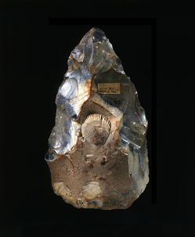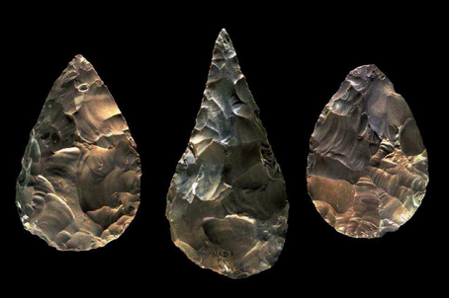

Fig. 1

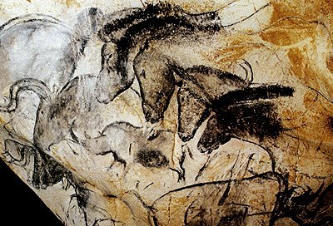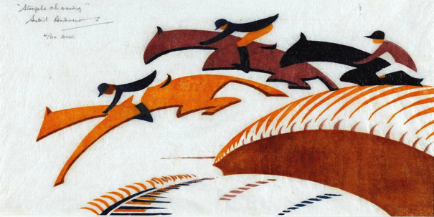

Fig. 2

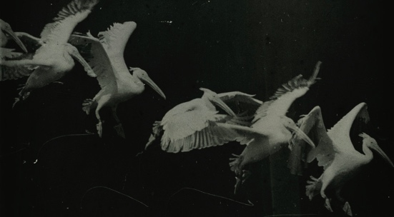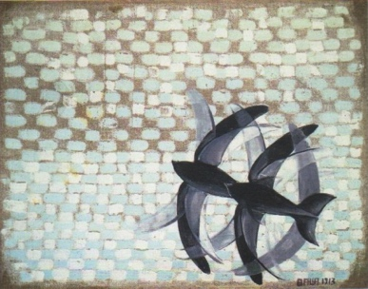

Fig. 3

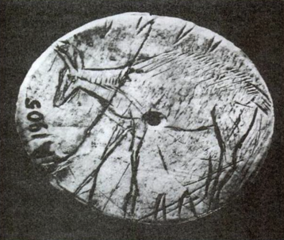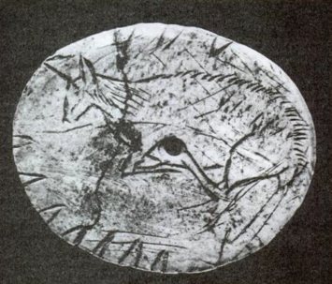

Fig. 4

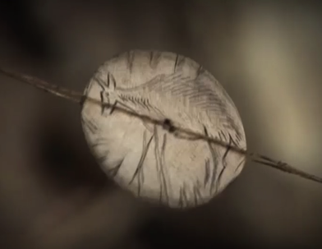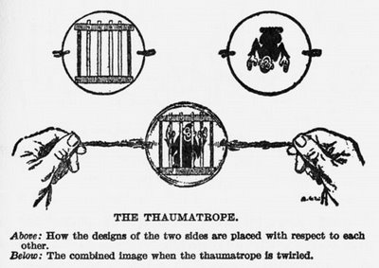

Fig. 5

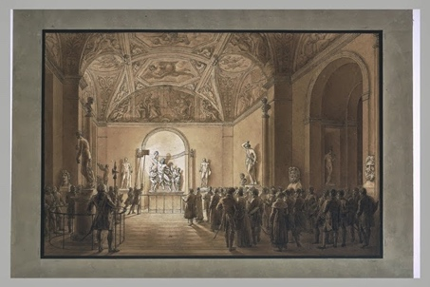

Fig. 6

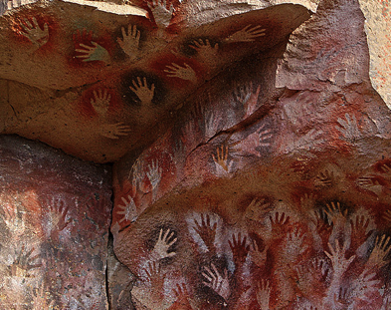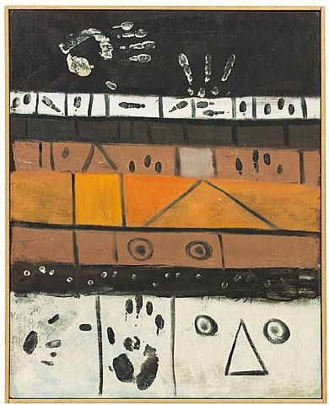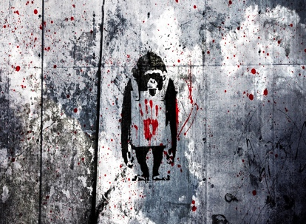

Fig. 7

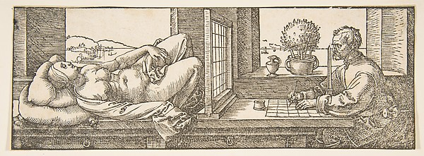

Fig. 8

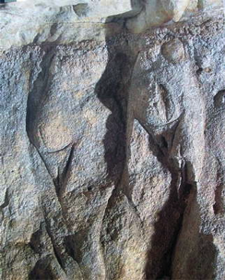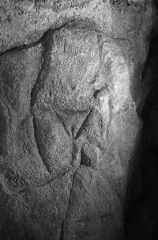

Fig. 9

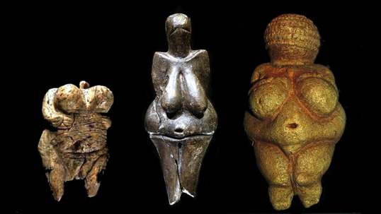

Fig. 10

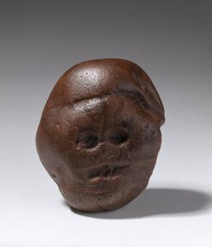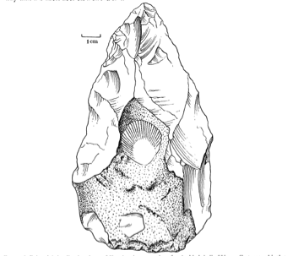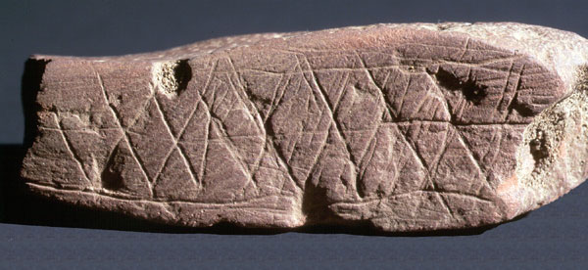

Fig. 11

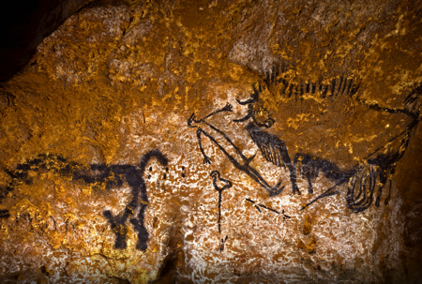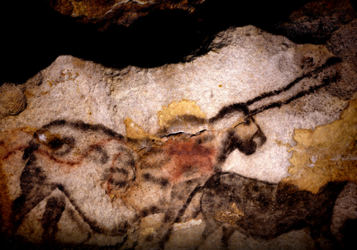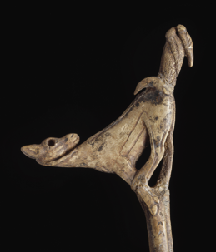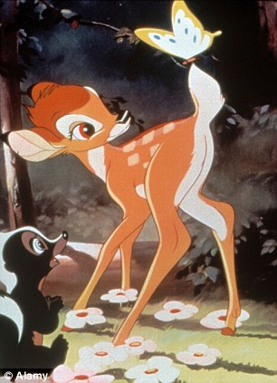

Fig. 12

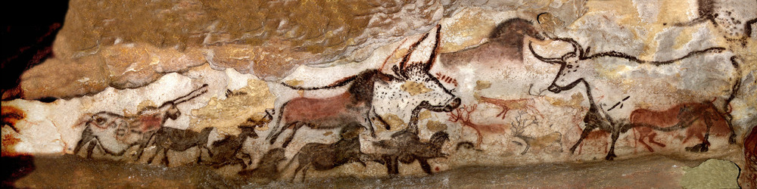

Fig. 13

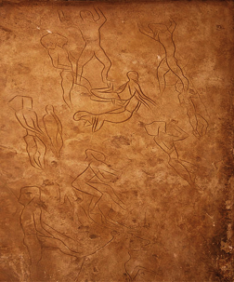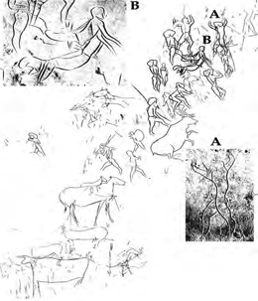

Fig. 14

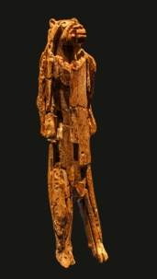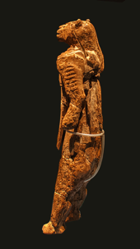

Fig. 15

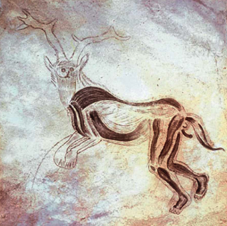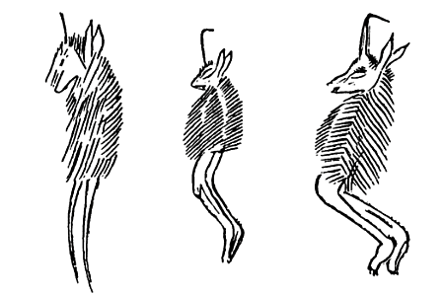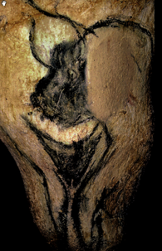

Fig. 16

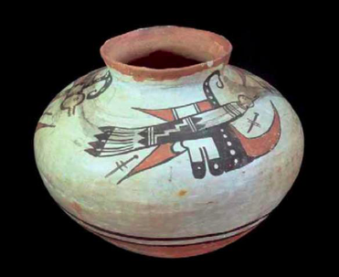

Fig. 17

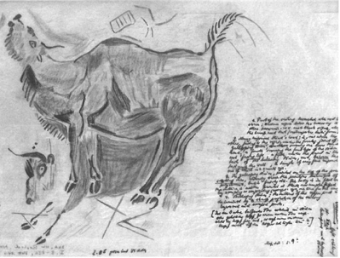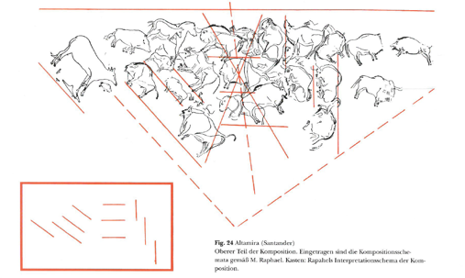

Fig. 18

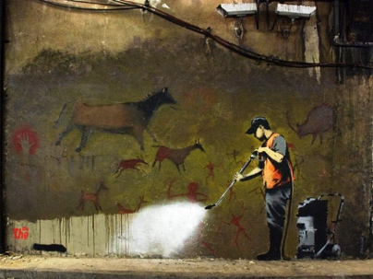

Fig. 19

